The Sunday Magazine

To rebuild the economy after COVID-19, we'll need more government, not less: Jim Stanford

'There's no way that the market economy is going to snap back from this catastrophe'
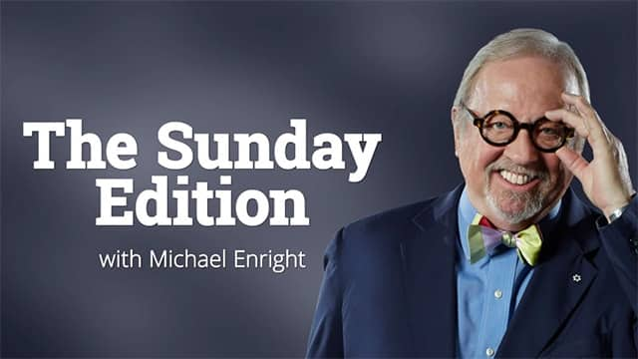
The Sunday Edition28:05To rebuild the economy after COVID-19, we'll need more government, not less: Jim Stanford
More than three million people in Canada have lost their jobs since the pandemic started. Another two and a half million have seen dramatic cuts to their working hours.
The economic shocks from the COVID-19 shutdown have been staggering. And the government has turned to unprecedented levels of spending in response, to try to keep workers, families and businesses afloat.
As calls to rebuild the economy grow louder, economist Jim Stanford says we need the federal government to continue to be big and bold — and to keep mobilizing everything.
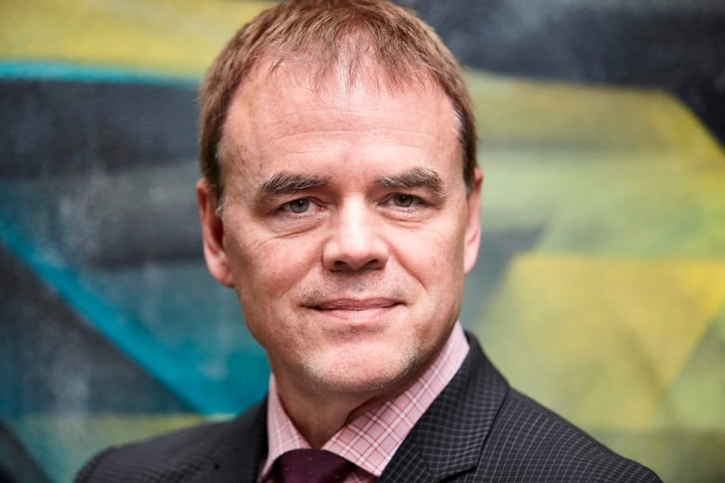
Jim Stanford is an economist and the director of the Centre for Future Work, a research institute with operations in Canada and Australia. (Submitted by Jim Stanford)
"There's no way that the market economy is going to snap back from this catastrophe," he told The Sunday Edition's Michael Enright. "It's going to need a post-war reconstruction program just like we had after World War II, and that implies a much larger role for government going forward."
Stanford is an economist and the director of the Centre for Future Work, a research institute with operations in Canada and Australia. He previously served as an economist and director of policy with Unifor, and before that with the Canadian Auto Workers. He is also the author of Economics for Everyone: A Short Guide to the Economics of Capitalism, which has been translated into six languages.
Here are excerpts from his conversation with Enright, which have been edited for clarity and condensed.

What makes this economic crisis different
This is a completely different order of magnitude. It's not comparable to any previous depression or recession or downturn that we've ever had in history, including the Great Depression of the 1930s.
We have gone to effectively Depression-level unemployment in Canada in a matter of weeks. I estimate that the true underlying level of unemployment right now is about 30 per cent, which does sound like the 1930s — but it took us years of stagnation and contraction to get to that level in the '30s; this time it happened in a matter of weeks.
And the rationale and mechanisms of the downturn are completely different. We actually deliberately shut down large parts of the economy because it was important for public health. So it isn't a garden variety downturn at all. It's something deeper and faster and differently motivated than anything we've ever experienced.
- After COVID-19, we will have 'the mother of all battles' over the future of the planet, says Charles Taylor

Who's been hit hardest
What was unusual with this recession is that it started in the services sector. Recessions typically start on the goods-producing side, in manufacturing or resources. And hence the people who were most directly affected are the people who work in the service industries. So there's more women who are affected than men. Young people, of course, fill a lot of those part-time jobs in retail and hospitality — they've experienced the most dramatic increase in unemployment.
It's also a very unequal recession. The people getting hit the hardest, by and large, are people who are working part-time or irregular hours or for low wages. People who've been able to keep their jobs include a lot of the managers and professionals who are able to take their laptop home and do their job from there. Many of them haven't lost at all.
At a time of crisis we need national government to be there, to be big, to be fast and to mobilize everything it can.- Jim Stanford

An expanded government role
This has actually been a real-time experiment that a national government — particularly one that has its own currency, as we do in Canada — has got basically no limits on how much money it can raise and mobilize in order to meet pressing emergencies, whether it's in our economy or in our society or health system.
This is absolutely unprecedented and it's quite appropriate. And it does confirm that at a time of crisis we need national government to be there, to be big, to be fast and to mobilize everything it can. It's kind of like fighting a war. We never stood back from World War II and said we can't afford to fight this war. We did what we had to do and we mobilized the resources, including the money to pay for it.
When people were genuinely fearing for their lives, you didn't hear anybody stand up and say we need smaller government, we need less red tape. But now, as the panic subsides a bit and the economy starts to gradually reopen, we are hearing some of those old voices. We heard former prime minister Stephen Harper weigh in this past week, for example, scolding all the governments that they have to downsize and get out of the way.
Their case was always weak. Every time they said that we were about to hit a debt wall, or we were miring our grandchildren in years and years of poverty and austerity, it was always false. We were never near a debt wall. But this time I think it rings especially hollow, because Canadians have seen firsthand the importance of government and the policies that it's brought in.
Frankly, the genie is out of the bottle. We've seen that the government can raise those resources and spend them wisely and protect us. And I think Canadians quite rightly are going to expect the government to continue playing that leading role.
Millions of Canadians have suddenly realized that we need those income support programs and they're not there for lazy welfare cheats. They're there for all of us at times of crisis.- Jim Stanford

Servicing the public debt
The great benefit of this situation is there's virtually no cost to servicing the debt. Interest rates were very, very low even before the coronavirus came along, and now they've been cut further.
We've had a shift in policy by our central bank, the Bank of Canada, to facilitate keeping interest rates extremely low and to facilitate the government borrowing these huge amounts of money.
In fact, in essence, indirectly, the Bank of Canada is providing the money for the federal government to undertake these huge programs. They're buying $5 billion of government bonds every week at least. And they've said they'll keep doing that until the economy is in a strong recovery mode. As long as that sensible approach is maintained and interest rates remain low, and there's no reason why they shouldn't, then servicing the debt is not going to be an issue.
What it comes down to are the political choices that we make as a society — what we're going to mobilize resources for.
The true rationale behind the cuts in the 1990s was not to get the debt under control. It was to construct a leaner, meaner, less forgiving, more insecure labour market. Those were choices we made as a society. It was never dictated by inevitable fiscal constraints. It was always about who had more influence in determining what we as a society spend on.
Now, millions of Canadians have suddenly realized that we need those income support programs and they're not there for lazy welfare cheats. They're there for all of us at times of crisis.
- COVID-19 pandemic reveals the risks of relying on private sector for life-saving vaccines, says expert

How the world of work will change
The pandemic is going to fundamentally change how we view work, how we perform work, how we protect and compensate workers, and what we expect from them. The labour market was already crying out for some really important changes and some of those fault lines have been exposed by the current crisis.
We've seen a whole dramatic rise in what we call precarious work over the last decade or two, to the point where almost half of Canadian workers now have some degree of precarity in their jobs. That rise of precarious work suited the interests of employers for a long time. It meant that their workforce was an ultra-flexible, just-in-time type of workforce that could be hired and fired at the drop of a hat.
But now we see enormous consequences for society. You've got a very large share of the workforce that doesn't have a thing called paid sick leave, for example. The same goes for income security programs: if the government hadn't moved quickly to expand the emergency benefit to include casual workers and gig workers and other people in precarious jobs, then millions of people would be literally left [with] nothing.
So those are things that we need to fix — and fix permanently — and I think there's an opening to do that.
Click 'listen' above to hear the full conversation.

